ONLINE MARKETING CONCEPTS
Tasks
1.Pick any two apps you use daily (like Instagram, Zomato, or Flipkart) and identify one online marketing technique each app uses to attract new users. Write a short explanation (2-3 lines) for each technique.
=> Answer :
App 1: Instagram – Social Media Marketing
Instagram uses social media marketing to attract and engage users through posts, Reels, Stories, and advertisements. It also uses personalized content to keep users active on the platform.

App 2: Flipkart – Discount & Promotional Marketing
Flipkart attracts new users through discounts, sale events, coupons, and special offers. These promotions encourage users to download the app and make purchases.

2.Create a simple digital flyer (image or PDF) for a new food delivery app launch, highlighting at least three online marketing concepts such as referral codes, limited-time offers, or influencer shoutouts.<br><br><em><strong>Hint:</strong> Use Canva or any free online design tool to make your flyer look engaging.</em>

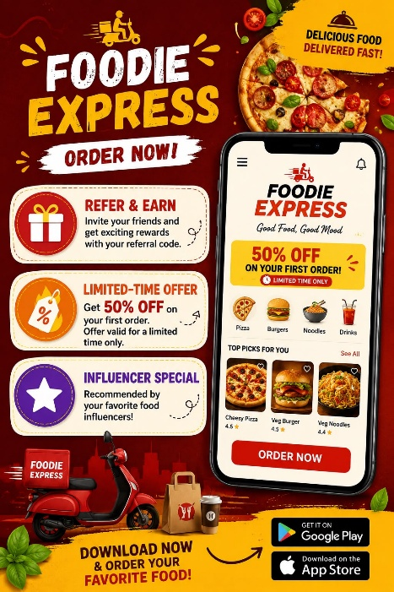

3.List five types of online ads you’ve seen while using YouTube, Instagram, or any other app. For each, mention which platform you saw it on and what made it noticeable or skippable.

Ad Type | Platform | Why is was Noticeble/Skippable
Video Ad | Youtube | It was attractive because of visuals and music.
Story Ad | Instagram | It appeared between stories and was short and engaging.
Sponsered Post | Instagram | It looked like normal concept but was marked as sponsored.
Banner Ad | Website | It was noticeable because of its position and design.
Skippable Video Ad | Youtube | I could skip it after a few second if it was not relevant.

4.Imagine you are launching a new playlist feature for a music app like Spotify. Write a short plan (5-6 lines) describing how you would use online marketing concepts (SEO, social media posts, email campaigns, influencer partnerships) to promote this feature.
=> Answer :
Marketing Plan:

1. I will use SEO to promote the new playlist feature through music-related keywords.
2. I will create engaging Instagram and Facebook posts to create awareness.
3. I will send email campaigns to existing users about the new feature.
4. I will collaborate with music influencers to promote the playlist.
5. I will create short Reels and YouTube videos showing the new feature.
6. I will encourage users to share the playlist with their friends on social media.

